This sample RFP is being provided as part of the August 17, 2015 Request for Information (RFI). This RFI shall not be construed to create an obligation on the part of PSEG Long Island to issue an RFP or enter into any contract on behalf of lipa, to serve as a basis for any claim whatsoever for reimbursement of costs for efforts expended by respondent firms or to modify the LIPA procurement process. The intent of this RFI is to gather legally permissible recommendations that may, be considered by pseg long island in preparing an RFP.

Request for Proposals

for

2015 Renewable RFP for
New, On-Island, Renewable Capacity and Energy

Issued by

PSEG LI

Issued October 14, 2015
Proposals Due April 8, 2016
TABLE OF CONTENTS
Page No.
1.0 Introduction 4
1.1 Company Overview 4
1.2 Description of Solicitation 4
2.0 General Terms 5
2.1 Product Definition 5
2.2 Contracting 6
3.0 Communications 7
3.1 Communications During RFP Process 7
3.2 RFP Website 8
3.3 Questions about the RFP 8
4.0 RFP Schedule 8
5.0 Proposal Process 10
5.1 General 10
5.2 Interpretation or Correction of RFP Documents 10
5.3 Pre-Bid Conference 10
5.4 Notice of Intent to Propose 10
5.5 Proposal Expenses 10
5.6 Proposal Submittal Fee 11
5.7 Method for Submitting Proposals 11
6.0 Proposal Organization 13
6.1 General Requirements 13
6.2 Cover Letter 13
6.3 Table of Contents 14
6.4 Disclosures 14
6.5 Company Data and Relevant Experience 14
6.6 Project Description 15
6.7 Technical Response 16
6.8 Project Execution Plan 17
6.9 Financial Plan 18
6.10 Pricing 19
6.11 Schedule 19
6.12 Power Purchase Agreement 20
6.13 Conditions Precedent for PPA/Contract 21
6.14 Technical Requirements, Siting and Guidance 21
6.15 Confidentiality 22
7.0 Proposal Evaluation And Selection 23
7.1 Evaluation Process 23
7.2 Evaluation Criteria 23
7.3 Notice of Award 25
7.4 Contract Approval 25
7.5 Debriefing of Unsuccessful Respondents 25
8.0 Reservation of Rights 26
8.1 General 26
8.2 Right to Reject 26
8.3 Limitations 26
9.0 MWBE Participation/ Equal Employment Opportunity 27
APPENDIX A 29
1.0 sCOPE 29
2.0 Reactive Power Capability and control 29
2.1 Reactive Power Capability in Normal Operation 29
2.2 Reactive Power Capability during Undervoltage Conditions 30
2.3 Reactive Power Control Capability 30
3.0 voltage and Frequency Disturbance Performance 32
3.1 Low-Voltage Ride Through 32
3.2 High-Voltage Ride Through 34
3.3 Voltage Disturbances within the Normal Magnitude Range 34
3.4 Frequency Response and Ride Through 35
4.0 Harmonic and interference Performance 36
4.1 Harmonic Current Limits 36
4.2 Harmonic Voltage Limits 36
4.3 Power Line Carrier Interference 37
4.4 Radio Frequency Interference 37
5.0 Control Performance 37
5.1 Stability 37
5.2 Control Interactions 37
6.0 transient and Temporary Overvoltages 38
7.0 Short-Circuit Contributions 39
8.0 Required Dynamic Models 39
8.1 Positive-Sequence Fundamental-Frequency Model 39
8.2 Electromagnetic Transient Model 40
Appendix B 41
Appendix C 42

* * * * *

Introduction

Company Overview
The Long Island Lighting Company d/b/a LIPA (“LIPA” or “Company”), a corporation organized and existing under the laws of the State of New York and a wholly owned subsidiary of the Long Island Power Authority, is a corporate municipal instrumentality and political subdivision of the State of New York. LIPA, by and through its agent, Long Island Electric Utility Servco LLC (“Servco”), a subsidiary of PSEG Long Island LLC (“PSEG Long Island” or “PSEG LI”), provides electric service to approximately 1.1 million LIPA customers in its service area, which includes Nassau County, Suffolk County, and the portion of Queens County known as the Rockaways, in the State of New York.
To meet its customers’ electricity requirements, LIPA has secured power supply resources, consisting primarily of various power purchase contracts with third-party generation and transmission developers; and has undertaken a variety of demand-side initiatives to reduce system peak demand (i.e., offered incentive programs to customers to encourage them to adopt energy efficiency measures, install wind and solar electricity-generating systems, and participate in Load Reduction events).
Pursuant to the Amended and Restated Operation Services Agreement (“A&R OSA”) dated December 31st, 2013, as it may be restated, amended, modified, or supplemented from time to time, between LIPA and PSEG LI, PSEG Long Island through its operating subsidiary, Servco, assumed the responsibility as LIPA’s service provider, to operate and manage LIPA’s transmission and distribution system (“T&D System”) and other utility business functions as of January 1st, 2014. On January 1st, 2015, PSEG LI assumed responsibility for LIPA’s power supply planning, and its affiliates provide certain services, such as purchasing power and fuel procurement, to LIPA related to these responsibilities. Additional information about LIPA and PSEG Long Island can be found on their respective websites - www.lipower.org and www.psegliny.com.
PSEG Long Island and Servco (collectively referred to as “PSEG Long Island”), as agent of and acting on behalf of LIPA per the A&R OSA, will administer this RFP on behalf of LIPA. Any Agreement for resources that are classified as Power Production (see Section B1, Appendix B) shall be entered into with LIPA.

Description of Solicitation

LIPA’s 2010-2020 Electric Resource Plan (the “Resource Plan”) was approved by the Trustees in February 2010.

By resolution dated October 25, 2012, the Trustees set forth the strategy for LIPA to execute on its Resource Plan, which set forth, among other things, a pathway to further diversify the supply portfolio available for its customers, and includes continued efforts to enhance existing renewable energy programs; future renewable energy procurements; replacing inefficient peaking units and other actions and investments that might be necessary and/or feasible to reliably and economically meet future load.

At the July 25, 2013 meeting of the Trustees, LIPA set forth its plan to, among other things, seek to add 400 MW of new renewable energy generation to LIPA’s resource portfolio by 2018 through an expanded feed-in-tariff program and a competitive procurement.

PSEG LONG ISLAND is issuing this 2015 Renewable RFP New, On-Island, Renewable Capacity and Energy (“2015 Renewable RFP”) for the addition of additional MWs of renewable energy, including all associated capacity and environmental attributes. While LIPA does not fall under the jurisdiction of New York State’s renewable portfolio standard (“RPS”), LIPA has adopted a goal to strive toward incorporating a larger percentage of renewable resources in its resource portfolio.

General Terms

Product Definition

Technologies being proposed must be considered as “renewable”, per the criteria established by the New York State RPS as defined in NY PSC Order, Case 03-E-0188 as of the execution date of the Power Purchase Agreement (PPA). Moreover, the proposed technology must be considered both proven and commercially available at the time of submittal. LIPA retains the right to determine in its sole discretion whether a specific proposed technology qualifies as "renewable".

For the purpose of clarity, all MW values discussed in this RFP are measured at the revenue meter.

The minimum renewable energy generating capacity for each project or point of interconnection is 2 MW nameplate capacity (AC).

Fuel-based renewables (e.g., biomass and fuel cells) are limited to a maximum capacity of 40 MW. LIPA will not award any more than 40 MW of contracts under this solicitation for fuel-based renewables.

Projects must follow and adhere to the interconnection procedures associated with the applicable Project capacity:

Projects less than 20 MW must adhere to LIPA’s Small Generator Interconnection Procedures (“SGIP”) which are posted on LIPA’s website, www.lipower.org. Additionally, projects need to comply with PSEG-Long Island Smart Grid Small Generator Interconnection Screening Criteria for Operating in Parallel with LIPA’s Distribution System where applicable.

For the purposes of clarity, a Respondent that proposes a renewable facility to be connected via a dedicated feeder to the LIPA system the limit is 10 MWs for a dedicated feeder. If a proposal is >10 MW, it must connect to the transmission system.

Projects 20 MW or larger must follow and adhere to the NYISO Large Generator Interconnection Procedures (“LGIP”).

All projects are subject to PSEG Long Island’s Long Island Local Reliability Interface Transfer Capability Test as posted on website (https://www.psegliny.com/files.cfm/LI-localreliability.pdfs.)Projects must follow and adhere to LIPA’s interconnection requirements, as provided on the RFP Website. Projects must successfully complete the LIPA interconnection process prior to interconnection. For further information on interconnection requirements Respondents should contact Steve Cantore of LIPA’s Power Asset Management Department at: (516) 949-8295.

Projects must be commercially operable and providing renewable energy and related capacity to LIPA on or before April 30, 2021.

Projects must be electrically connected to the LIPA transmission and distribution system or provide a new transmission line or new transmission capacity onto Long Island.

Storm Resistant Location/Facilities: All project facilities and interconnection facilities must be designed to withstand 130 mph winds and to elevate equipment to accommodate updated one-in-500 year flood zones.

Contracting

The selected Respondent(s) will be required to execute a 20-year power purchase agreement (“PPA”) with LIPA. A standard form of PPA will be available on the RFP website. This standard form of PPA will contain optional contract provisions that may be specific to particular technologies, financing arrangements or corporate structures. Each Proposal shall identify which optional contract provisions are being selected.

The standard form of PPA contains a number of blanks for project specific information. Each proposal shall provide a “red-line” mark-up to the form of PPA that fills in the blanks with all available project specific information.

The preference is that contract executed with selected proposals will follow the standard form of PPA without exceptions. In some circumstances, it may be necessary to negotiate exceptions to the standard form of PPA. If the Respondent has exceptions to the standard form of PPA, the red-line” mark-up shall any insertions, deletions, or other proposed changes, which must include proposed text, as applicable. Each proposed changes shall be documented by comments explaining the necessity for the change. Respondent modifications that are not clearly identified and justified will not be negotiated in the contract.

Redlines shall only be provided using “Track Changes” in Microsoft Word.
* * * * *

Communications

Communications During RFP Process

Pursuant to State Finance Law sections 139‐j and 139‐k, this RFP includes and imposes certain restrictions on communications between LIPA and Respondents during the procurement process. A Respondent is restricted from making contacts (i.e., an oral, written or electronic communications which a reasonable person would infer as an attempt to influence the award, denial, or amendment of a contract) with any LIPA representative, other than as designated herein, from date of issuance of the RFP through the final award and approval of the resulting Procurement Contract (as that term is defined under State Finance Law) by LIPA and the Office of the State Comptroller (the “Restricted Period”), unless it is a contact that is included among certain statutory exemptions as set forth in State Finance Law sections 139‐j(3) (a). LIPA staff and Board of Trustees, and advisors are required to obtain certain information when contacted during the Restricted Period and make a determination of the responsibility of the Respondent pursuant to these two statutes. Certain findings of non-responsibility may result in rejection for contract award, and in the event of two findings within a four-year period, the Respondent is debarred from obtaining governmental Procurement Contracts.

LIPA’s Designated Contacts for this RFP include:
      - TBD
      - TBD
      - TBD

Designated contacts will be updated and/or supplemented as needed and all such changes will be posted on the RFP website.

Other than as provided for in this RFP, any contact with LIPA’s Board of Trustees, staff, or advisors regarding the RFP during its pendency may be grounds for disqualification from the RFP process.

Further information about these requirements can be found in the Lobbying Guidelines Regarding Procurements, Rules, Regulations or Ratemaking, which is posted on the RFP website.

RFP Website

For further information, please refer to the 2015 Renewable RFP website that is accessible through PSEG Long Island’s website (www.psegliny.com). Please look in the “About Us” folder under “Proposals”. The below RFP Schedule is based upon expectations as of the release date of this RFP. PSEG Long Island may modify the RFP Schedule at its sole discretion. The RFP website is a public site, accessible to anyone at any time and does not require a password or login information to view the RFP contents. The RFP website allows Respondents to download documents referenced in the RFP. The RFP website contains a Questions and Answers (“Q&A”) section.

The RFP website also has a contact list for various governmental entities that may be able to provide guidance to potential Respondents regarding preferred sites for the installation of renewable resources.

Request for Transmission Data: Respondents may request certain transmission system data to assist them in developing their proposals. LIPA will provide interested Respondents a load flow, contingency list, and a one-line diagram around an electrical bus at a proposed interconnection point. Respondents should submit a request via the RFP website and will be required to execute a non-disclosure agreement.

Questions about the RFP

All questions and clarifications concerning these RFP Documents shall be electronically submitted to the RFP email address. Such questions or clarifications must be submitted by the “RFP Question Submittal Deadline”, as specified in the RFP Schedule, in order to be considered. All inquiries should be asked via the following email address: 2015renrfp@pseg.com.

All questions and answers concerning this RFP will be publically available (on an anonymous basis) to all potential Respondents through the RFP Website.

RFP Schedule
The following RFP Schedule is based upon LIPA’s expectations as of the release date of this RFP. LIPA reserves the right to modify the RFP Schedule at its sole discretion.
Table 1: RFP Schedule
If PSEG Long Island issues an RFP on behalf of LIPA, the issue date will be different than illustrated in this table. The dates in the table are intended to illustrate the current position of the time between various steps in the RFP process.

ACTIVITY | DATE
Release of RFP | October 14, 2015
Pre-bid Conference Webinar | November 10, 2015
Question Submittal Deadline | March 11, 2016
Proposal Submittal Deadline | April 8, 2016, 3:00pm EST
Proposal Selection(s) (planned) | December 9, 2016
Execution of Contract(s) (planned) | ^{3rd} Quarter 2017
Firm Pricing Required Through | November 30, 2017
Latest COD (planned) | April 30, 2021
* * * * *

Proposal Process

General

Complete sets of the RFP Documents may be obtained from the RFP Website.

PSEGLI assumes no responsibility for errors or misinterpretations resulting from the use of incomplete sets of RFP Documents.

Proposals shall include, at a minimum, each of the required elements summarized in Section 6.0 herein.

Interpretation or Correction of RFP Documents

Any Respondent who discovers any ambiguities, inconsistencies, omission or error or is in doubt as to the meaning or intent of any part of the RFP documents shall request an interpretation from PSEGLI. Such interpretation shall be made in writing to PSEGLI.

If a Respondent fails to notify PSEGLI of a known error or an error that reasonably should have been known prior to the final filing date for submission, Respondent shall assume the risk, and shall not be entitled to alter its proposal after the submission deadline.

Modifications to the RFP Documents will be furnished by PSEGLI via the RFP Website.

Pre-Bid Conference

No pre-bid conference will be held.

Respondents are encouraged to submit written questions or other requests for information through the process described herein.

Notice of Intent to Propose

Respondents are encouraged to provide a “Notice of Intent to Propose” to the Designated Contact(s) at any time prior to the Proposal Submittal Deadline. Such notice shall contain the Respondent’s name, corporate address, and phone number as well as the name, address, phone number, and email address for Respondent’s primary point of contact.

Proposal Expenses

Respondents shall bear any and all labor, materials and content costs and expenses required for or in connection with preparation of its Proposal; subsequent actions taken by Respondent up to the execution of the PPA, including clarification of the Proposal and negotiation of the PPA; all taxes, duties, fees, and other charges that may be associated with completion of the Project; and compliance with all local, state, and federal laws that may affect the Project and the PPA.

Proposal Submittal Fee

Each Proposal shall be accompanied by a submittal fee in the amount stipulated below:

Each Project with nameplate capacity below 20 MW: $1.50 per kW

Each Project with nameplate capacity of 20 MW or more: $2.50 per kW

Proposals shall be submitted with the applicable submittal fee in the form of a certified check or bank check made payable to the Long Island Power Authority. Proposals without the required fee will be returned to Respondent, and such Proposals will not be considered or evaluated by LIPA.

The submittal fee will only be returned in cases where the Proposal is not submitted by the Proposal Submittal Deadline. Otherwise, this submittal fee is non-refundable and will not be returned or credited to any Respondent, including the successful Respondent(s).

Method for Submitting Proposals

Proposals are limited to one point of interconnect. Multiple proposals by a single bidder are permitted.

Bidders submitting multiple proposals must identify if any are mutually exclusive from other Proposal(s) from that Respondent.

Proposals shall be submitted in the complete name of the party expecting to execute any resulting contract with LIPA. The Proposal shall be executed by a person who is duly authorized to bind Respondent to a contract.

Proposers who submit a renewable project in the 2015 South Fork Resources RFP may submit the same proposal in this RFP, but must clearly identify this in both RFPs on the Cover Page.

All Proposals submitted in response to this RFP must be received by the Proposal Submittal Deadline. Proposals received after this deadline will not be opened and will be disqualified from further evaluation.

Four (4) bound hard copies of each Proposal and one (1) electronic copy of each Proposal (sent via CD, DVD, or flash drive) shall be submitted to LIPA at the following address:

Ms. Gracia DeSilva
PSEG Long Island
333 Earle Ovington Blvd., Suite 403
Uniondale, New York 11553

Hard copies of Proposals shall be bound and clearly marked with:

Project name.

Project nominal capacity (MW) and technology type(s).

RFP title (2015 Renewable RFP).

Name and address of Respondent.

Identification as to whether this proposal is a “Mutually Exclusive Proposal” or has also been submitted in the South Fork Resources RFP.

Hard copies of proposals should include clearly-labeled tab dividers between each section.

Proposals sent by facsimile or email are not acceptable. Such Proposals will not be evaluated or considered.

Proposal Organization

General Requirements

Proposals shall include each of the required elements summarized herein. This applies to each Proposal that is submitted by Respondent (i.e., each Proposal shall stand alone in satisfying these requirements).

Proposals that do not include the required information will be deemed non-responsive and will not be evaluated. Non-responsive proposals include, but are not limited to, those that:

Are not in conformance with RFP requirements and instructions.

Are conditioned on some other act or omission (other than as required by law) whether or not related to this procurement and the resulting contract. Without limiting the generality of the foregoing, by way of example, a proposal that requests extension of an existing contract with the same company is a conditional proposal.

Do not include the required Proposal Submittal Fee.

Contain any material omission(s).

Do not meet the submission requirements set forth herein.

Respondent may submit complementary information not explicitly requested within the RFP Documents. Such information shall be provided in addition to, not in lieu of, the requested information.

All documents, schedules, and other similar items submitted as a part of a Proposal are to be clearly labeled and organized in a fashion that facilitates easy location and review.

Respondent may submit complementary information not explicitly requested within the RFP Documents. Such information shall be provided in addition to, not in lieu of, the requested information.

Cover Letter

The cover letter shall include an “executive summary” of the highlights and special features of the Project or Proposal.

The cover letter shall be signed by Respondent’s primary point of contact and the individual(s) that are duly authorized by the Respondent to make a binding offer to LIPA.

The cover letter shall include contact information for Respondent’s primary point of contact, including name, title, address, phone, email, and fax.

The cover letter shall contain a statement clearly indicating the time period during which the Proposal (including pricing) will remain effective. At a minimum, the Proposal must remain effective through the “Firm Pricing Required Through Date” noted in the RFP Schedule.

Table of Contents

Proposals should include a table of contents that clearly lists all items submitted in response to this RFP.

Disclosures

Respondent shall provide a disclosure of any instances in the last five years where Respondent, any of its officers, directors or partners, any of its affiliates, or its proposed guarantor (if any) defaulted or was deemed to be in noncompliance with any obligation related to the sale or purchase of power (capacity, energy and/or ancillary services), transmission, or natural gas, or was the subject of a civil proceeding for conversion, theft, fraud, business fraud, misrepresentation, false statements, unfair or deceptive business practices, anti-competitive acts or omissions, or collusive bidding or other procurement- or sale-related irregularities.

Respondent shall provide a disclosure of any instances in the last five years where Respondent, any of its officers, directors or partners, any of its affiliates, or its proposed guarantor (if any) was convicted of (i) any felony, or (ii) any crime related to the sale or purchase of power (capacity, energy and/or ancillary services), transmission, or natural gas, conversion, theft, fraud, business fraud, misrepresentation, false statements, unfair or deceptive business practices, anti-competitive acts or omissions, or collusive bidding or other procurement- or sale-related irregularities.

Respondent shall provide a signed and completed Contractor Disclosure of Prior Non-Responsibility Determinations, MacBride Fair Employment Principles, Contingent Fee Certification, Non-Collusive Bidding Certification and New York State Vendor Responsibility Questionnaire/Certification forms, as available on the RFP website.

Company Data and Relevant Experience

Proposals must contain:

Company name, address and telephone number (and name, address, telephone number, and e-mail address of the contact person for Proposer in connection with its Proposal);

Legal status (e.g., corporation, partnership, limited liability company), date formed, jurisdiction of organization, and identification of any relevant affiliates;

Ownership status (e.g., privately held or publically traded);

Guarantor information (same information as subparagraphs A and B in this section) if applicable;

If a consortium submits a Proposal in response to this RFP, the consortium will clearly provide information on its legal form and each of its members, and identify the member responsible for providing all financial security, executing the PPA, and providing Products to LIPA (the “Lead Member”).

Company history and experience in the areas of development, financing, construction, and operation of electric generating plants;

Familiarity and experience with NYISO requirements; and

Existing electric generating plants owned and/or operated by Proposer.

Project Description

Provide a full and complete description of the proposed Project including technology, nominal capacity (both real and reactive), size (acreage), existing site conditions, nearby structures and facilities, and environmental conditions or requirements.

Provide a full and complete description of the businesses surrounding the location of the proposed Project, if any.

The proposed Project shall be located on a site controlled by Respondent through either fee ownership, a land lease, option to lease or purchase, or equivalent demonstration of site control. Respondent shall provide evidence of such site control or its plan to obtain site control in its Proposal.

Site characteristics (including identification of the zoning for the site and a description of whether the proposed project is a permitted use under the local zoning code; a discussion of any known sensitive environmental features on or adjacent to the site such as wetlands, historic properties, ongoing hazardous materials remediation, residences or other sensitive noise receptors; and a discussion of storm resistant features and other reliability features);

Proof of appropriate local zoning or confirmation in writing from the involved municipality that a change in zoning will occur one month prior to the “Proposal Selection(s) (planned)” date in Table 1 or a waiver from the involved municipality, is a requirement of this RFP.

If permits have already been obtained, proposer shall provide copies, and if not, proposer shall provide a plan and schedule for obtaining all required permits.

All permits must comply with any County, Town or Local Municipality regulations that have been established with respect to renewable installations.

Technical Response

Technology Description:

Provide a full and complete description of the technology being proposed. Respondent shall include a listing of all Projects in which Respondent has previously incorporated this technology, including the size (MW), location, and commercial operation date of each.

Provide projected availability factor, or the percent of time during a specified period that the facility is capable of providing service. All assumptions (including periods of exclusion or carve-out) in deriving this availability factor should be specified.

Provide a summary of planned outages, or the percent of time during a year that the facility is scheduled to be out of service for routine maintenance.

Describe to what extent the Project can provide/absorb MVARs to control voltage.

One-Line Diagram:

Provide a comprehensive one-line diagram describing the electrical equipment and point of interconnection or deliverability to LIPA’s electric system. LIPA reserves the right to re-designate the facilities’ interconnecting substations / Transmission and Distribution points of interconnection as needed to meet reliability and/or cost considerations. In such an event, proposed PPA charges will be adjusted to compensate for any increase or decrease in the cost of the Developer Attachment Facilities.

Compliance with LIPA’s SGIP, the NYISO’s LGIP requirements, and LIPA’s Long Island T&D Design Criteria is required.

Respondents may request certain transmission system data to assist them in developing their proposals. LIPA will provide interested Respondents a load flow, contingency list, and a one-line diagram around an electrical bus at a proposed interconnection point. Respondents should submit a request via the RFP website and will be required to execute a non-disclosure agreement.

Site Layout:

Provide a layout of the Project site using a white background, including site boundaries, access, location of equipment and buildings, and routing of the transmission line from the Project to the point of interconnection.

Provide a layout of the Project using an aerial background, including site boundaries, access, location of equipment and buildings, and routing of the transmission line from the Project to the point of interconnection.

For solar PV projects, provide at a minimum, the following information:

percent of lot to be covered by solar panels

setback from property line to nearest solar panel or inverter

maximum height of any structure

description of natural screening designed into the project

Data Sheet:

Complete the appropriate data sheet for the technology being proposed. The data sheets are included on the RFP Website in a Microsoft Excel file.

Provide Dependable Maximum Net Capability (“DMNC”) according to NYISO Standards including (i) expected seasonal peak capacity (MW) for summer and winter and (ii) expected output at ISO conditions.

Print the data sheet(s) and include a hard copy within the Proposal as well as submit the completed data sheet(s) electronically in Excel format.

Annual Energy Production Forecast :

Provide an average (P50) annual net energy production forecast (MWhs). This forecast shall represent the average net annual energy delivered to LIPA at the point of interconnection.

Provide an average (P50) hourly net energy production forecast. This forecast shall represent the average hourly net energy delivered to LIPA at the point of interconnection. The 8760 forecast shall be submitted electronically to the Designated Contact(s) using the Excel format specified in the corresponding attachments available on the RFP Website. Do not submit the full 8760 forecast in hard copy format.

Provide an uncertainty forecast for the net energy production estimates. This forecast shall present a summary of all estimated uncertainties. Proposals shall include corresponding estimates for P90, P95, and P99 net annual energy production.

Provide a description of the assumptions, data, and calculations used to prepare these forecast.

Project Execution Plan

Respondents shall provide a brief description of how they intend to complete the Project and deliver renewable energy to LIPA.

A description of the major engineering, procurement, and construction (“EPC”) contractors the Respondent intends to utilize shall be included. Describe the nature of its labor force and how they expect to complete the Project without labor delays.

Respondents shall describe the status of development and permitting, including a detailed list of all permits received and any permits needed prior to achieving commercial operation of the Project.

Respondents shall be required to keep LIPA informed of Project progress during development; therefore, Respondents shall provide a description of the process that would be used to update LIPA on Project progress and changes in the projected installation schedule.

Respondents shall provide a community outreach plan, including evidence of community support, if any, for the proposed project, which can be in the form of correspondence from local elected officials and community groups.

The Respondent should identify any New York State or Long Island based companies that will be involved in this project.

Financial Plan

Proposals must contain evidence of Respondent's and any Guarantor's financial condition and financial capacity to complete and operate the proposed project as evidenced by a “Financing Plan.” Proposals must provide:

A detailed description of proposed short- and long-term financing arrangements.

A list of all equity partners, sources of equity and debt, debt structure.

Demonstrate that financial arrangements are sufficient to support the project through construction and the PPA term.

Describe proposed capital structure for the project.

A schedule showing all major projects developed and financed by Respondent in the past 10 years.

Provide details of any events of default or other credit issues associated with all major projects listed in subparagraph E above.

Identify proposed Guarantor(s) for the Project and provide documentation of the Guarantor’s creditworthiness including the three most recent audited financial statements of the Guarantor).

Information concerning the Respondent’s financial condition and evidence of creditworthiness including:

Audited financial statements for its three most recent fiscal years; or

Audited financial statements from Respondent’s parent, if Proposer does not have such financial statements; or

Statement describing why the statements in either 6.9.10 or 6.9.11 cannot be provided and provide alternate information to demonstrate Respondent’s financial capacity to complete and operate the proposed project.

Include four references from prior projects developed by the Respondent that employed financing arrangements similar to the arrangements contemplated by the Proposer for the project.

Pricing

All proposed contract pricing must be firm and all terms and conditions must be open for acceptance by LIPA through November 30, 2017.

Firm pricing shall be a fixed $/MWh price for Energy provided for the term of the contract. The total cost of each project will be determined via the levelized cost and all-in-cost analyses as described in Section 8 of this RFP.

A detailed description of the pricing terms, conditions, and assumptions shall be included.

The Cost of Developer Attachment Facilities recovered through the price shall be disclosed.

The Cost of System Upgrade Facilities recovered through the price shall be disclosed.

Proposals must comply with the requirements set forth in section 2.1, as applicable. In keeping with LIPA’s policy of non-discriminatory access to its transmission system, Respondents will be responsible for reimbursing LIPA (as Connecting Transmission Owner) for all attachment facilities and system upgrades constructed and owned by LIPA. Respondents may seek to recover such costs through PPA charges.

Proposed pricing shall be all-inclusive, including all necessary development, design, procurement, permitting, financing, construction, and operational costs as further described in this RFP.

Schedule

Proposals shall include a proposed Project development schedule (e.g., permitting, environmental review, financing, construction, testing and commercial operation), including, but not limited to:

Timing for all permits and milestone dates;

Transmission interconnection process and milestone dates;

Financing milestone dates;

Engineering and design timing and dates;

Major equipment purchase dates;

Contracting dates and milestones;

Construction timing; and

Commercial operation date.

The following guidelines shall be used in preparation of the proposed Project schedule:

Include Respondent name prominently on each page of the schedule.

Utilize monthly timescales.

Prepare the schedule in graphic format as horizontal bar charts (i.e., Gantt) in landscape orientation.

Provide task name, duration, start date, completion date, and predecessors for each task.

Identify clearly all critical path activities.

Utilize sheet sizes no larger than 11x17 inches.

Power Purchase Agreement

As set forth in Section 2.2 above, each Proposal shall include a “red-line” of the form of PPA with any comments, insertions, deletions, or other changes, which must include proposed alternative text, as applicable. Alternatively, if the Proposer accepts the Form of PPA “as is”, provide a statement accepting the LIPA form of PPA.

Redlines shall be provided using “Track Changes” in Microsoft Word.

Respondent modifications that are not clearly identified using “Track Changes” will not be evaluated.

Conditions Precedent for PPA/Contract

For a proposed project subject to Article 10 of the New York Public Service Law, a condition precedent to the PPA becoming effective is that the Proposer must receive a certificate of environmental compatibility and public need from the New York State Board on Electric Generation Siting and the Environment. For a proposed project that is subject to the New York State Environmental Quality Review Act (“SEQRA”), LIPA cannot execute the PPA until the SEQRA review is complete.

Technical Requirements, Siting and Guidance

All generation resources offered in response to this RFP that are to be directly interconnected with the LIPA transmission system and use means of conversion of mechanical or electrical power to alternating current or voltage at the system nominal frequency (60 Hz) by other than synchronous generators must comply with the requirements listed in Appendix A. The requirements of Appendix A do not supersede the requirements of the SGIP or the LGIP. Appendix A is in addition to those documents. Appendix A is solely for transmission-connected non-synchronous generation. Synchronous renewables must comply with the existing interconnection and reliability requirements. Distribution-connected renewables are required to use inverters that have “smart inverter” capabilities compliant with California Public Utility Commission Electric Tariff Rule 21.

To provide guidance to prospective Respondents with regards to points of interconnection within the LIPA Service Territory PSEG LI has included Appendix B. This Appendix lists those LIPA Substations that are at or very near their maximum injection capacity and therefore would necessitate extensive modifications to those substations in order to incorporate the injection of new resources. The cost of those modifications would be included in the overall cost of a given project during the quantitative evaluation.

To provide guidance to prospective Respondents with regards to regions of LIPA’s Service Territory that would benefit from the injection of power PSEG LI included Appendix C. Details regarding specific substations in these regions that can accommodate injection can be gained during the consultation with PSEG LI’s Power Asset Management Department.

In the event that multiple resources are proposed in close proximity within a given geographic area of the LIPA Service Territory and nearby substations cannot accommodate the injection of the combined power PSEG LI will consider constructing a substation for this purpose if it is economically viable. There are certain governmental entities that support the installation of renewable resources. In order to facilitate cooperation between prospective Respondents and those governmental entities, PSEG LI will place a contact list for those entities on the PSEG LI website.

Confidentiality

As a corporate municipal instrumentality of the State of New York, documents in LIPA’s possession are presumptively available to the public under New York’s Freedom of Information Law (“FOIL”), Public Officers’ Law (“POL”) Article 6. Respondents are strongly encouraged to familiarize themselves with the obligations and requirements of FOIL.

Respondents shall indicate in their proposals, consistent with Section 87(2) of the POL, what information, if any, should not be made publicly available by marking such information as confidential.

Information marked confidential will be treated as such to the extent consistent with LIPA’s obligations under FOIL, other applicable law, regulation, or legal process, and will not be disclosed by LIPA except as required by law, or as necessary for the evaluation of proposals.

In the event that LIPA receives a FOIL request for any or all proposals submitted in response to this RFP, LIPA will notify the submitting entity of the FOIL request pursuant to Section 89(5) of the POL.

* * * * *

Proposal Evaluation And Selection

Evaluation Process

PSEG LONG ISLAND may select one or more proposals for contract award.

LIPA reserves the right to waive non-material deviations in a proposal. Non-material deviations are deviations and/or omissions the waiving of which, at LIPA’s sole discretion, do not disadvantage LIPA, do not provide a competitive advantage to the Respondent and/or will not prejudice other Respondents or potential Respondents.

Proposals determined to be responsive will be evaluated by a Selection Committee consisting of PSEG LONG ISLAND staff (assisted by advisors) that will evaluate such proposals based on the evaluation criteria set forth below.

The Selection Committee may request Respondents to clarify proposals for the purpose of assuring PSEG LONG ISLAND a full understanding of their response to the RFP. PSEG LONG ISLAND may choose to conduct interviews and/or site visits with Respondents to further clarify aspects of their Proposals. If interviews and/or site visits are conducted, PSEG LONG ISLAND will notify the affected Respondent(s) of the scheduled date(s).

The Selection Committee may designate more than one potential selection (each a “Finalist”) and may request each Finalist to submit a Best and Final Offer prior to making its selection recommendations.

Prior to award of any contract, the Selection Committee will conduct a vendor responsibility determination and may require eligible Respondents to answer questions and provide additional information to supplement the information provided in the NYS Vendor Responsibility Questionnaire posted on the RFP website to assist the Selection Committee in making such a determination.

Evaluation Criteria

The Selection Committee will evaluate the Proposals in accordance with the following “Quantitative Evaluation Criteria” and “Qualitative Evaluation Criteria” (items not necessarily listed in the order of importance) for each.

Quantitative Evaluation Criteria includes the “all-in” costs of the Proposal to LIPA’s customers. This evaluation includes an assessment of the net present value and annual costs that the proposed project would impose on the Authority’s customers, taking into consideration factors including, but not limited to:

PPA charges, including a listing of all pass through costs and fuel costs, where applicable

Costs for required transmission reinforcements

System impacts including, but not limited to the avoided cost of capacity and energy, and the impact on Operating Reserve Requirements, Transmission Transfer Capability, Reserve Requirements, NYISO capacity requirements, IR-5 gas rules, deliverability, and ancillary services

Beneficial system impacts from demonstrating the ability to meet a 2019 or 2020 or earlier COD

An assessment of the financial impact of the Proposal on LIPA’s purchases and sales from the capacity and energy markets including operating reserves

Qualitative Evaluation Criteria:

Feasibility of the fuel supply plan, where applicable

Development and schedule risk

Site Control

Site Characteristics

Ability to Permit Project

Existence of required zoning or guaranteed zoning modification to complete the project

Ability to Meet Proposed In-Service Date

Exceptions to PPA, if any

Quality of Proposal
- Financing Plan
- Financial Qualifications
- Management Experience
- Experience with development on Long Island
- Equipment selection
- Contractor experience

Feasibility, timing and cost of electric and/or gas system interconnections and upgrades

Integration with LIPA System, including ability to meet a COD earlier than April 30, 2021

Demonstrated record and depth of experience in developing, owning, and operating renewable or other power generation systems

Price certainty and risk of price increases

Community acceptance. In order to satisfy this aspect of the Qualitative Analysis the Respondent MUST include with their submitted proposal(s) documentation from recognized community groups and elected officials from the locality surrounding the project site that the project will be accepted by the community.

Environmental impacts

Use of suppliers and subcontractors in New York State (particularly on Long Island).

Notice of Award

All Respondents will be notified in writing once the successful Respondent(s) has been selected.

Contract Approval

PSEG LONG ISLAND’s selection of the successful Respondent(s) shall not be binding until it has been approved by LIPA’s Board of Trustees. Upon approval of LIPA’s selection by its Board of Trustees, PSEG LONG ISLAND and the selected Respondent(s) will negotiate and execute contracts for selected amount of power associated with the renewable resource(s). Any such contract(s) shall not be valid, effective or binding until approved by the New York Attorney General and Office of State Comptroller and filed in his office, in accordance with Section 112 of the New York State Finance Law. No payment for services rendered can be made under the contract until such approval is obtained.

Debriefing of Unsuccessful Respondents

Upon written request to the Designated Contact(s), an unsuccessful Respondent may request a debriefing with PSEG LONG ISLAND staff. Debriefings will be scheduled after PSEG LONG ISLAND has provided notice of its selection of the successful Respondent(s).

Discussions during any such debriefing will be limited to an analysis of the evaluation of the Proposal submitted to PSEG LONG ISLAND by the Respondent requesting the debriefing. Comparisons between Proposals or evaluations of the other Proposals will not be discussed.

Debriefings may be conducted in person or by telephone, at PSEG LONG ISLAND’s discretion.
* * * * *

Reservation of Rights

General

This RFP is not an offer or commitment but rather an invitation to make an offer and is not capable of being accepted to form a binding agreement.

All material submitted in response to this RFP will become the sole property of LIPA.

Following selection, a Respondent may be required to participate in negotiations and to submit any price, technical or other revisions to its Proposal which may result from such negotiations.

LIPA reserves the right to procure renewable resources through other means in addition to this RFP.

Right to Reject

This RFP does not commit LIPA to award a contract, pay any costs associated with the preparation of a proposal, or procure or contract for any project whatsoever. LIPA reserves the right, in its sole discretion, to accept or reject any or all responses to this RFP, to negotiate with any and all Respondents susceptible of being selected for award, or to cancel this RFP in whole or in part and to pursue other resource alternatives which may include negotiating with entities that were not Respondents.

Limitations

Respondents may be requested to clarify the information in their proposals, but they may not alter their proposals or otherwise submit any additional information after the proposal due date.

While LIPA has endeavored to supply useful information in this RFP and the associated website, PSEG LONG ISLAND makes no representation or warranty, express or implied, as to the accuracy or completeness of any information contained herein or otherwise provided to any Respondent by or on behalf of PSEG LONG ISLAND. Respondents are encouraged to conduct their own investigation and analysis of any and all information contained herein or otherwise provided by or on behalf of PSEG LONG ISLAND.

* * * * *

MWBE Participation/ Equal Employment Opportunity
NYS MWBE Participation/Equal Employment Opportunity
- LIPA and PSEG Long Island are committed to diversity and equal employment opportunities among its contractors. LIPA and PSEG Long Island encourage all firms, including firms that are MWBE certified, to submit proposals in response to this RFP. All certified MWBE firms submitting proposals to this RFP should be registered as such with the NYS Department of Economic Development. Firms that are not certified but have applied for certification shall provide evidence of filing, including filing date.
- For purposes of this solicitation, LIPA and PSEG Long Island hereby establish an overall subcontracting goal of 30% (15% for Minority-Owned Business Enterprises participation and 15% for Women-Owned Business Enterprises participation).
- Respondents shall include their Minority Business Enterprise (MBE) and Woman Business Enterprise (WBE) proposal data, including a utilization plan detailing how the 15% MBE and 15% WBE participation goals will be met (see MWBE Attachment B, “PARTICIPATION BY MINORITY GROUP MEMBERS AND WOMEN WITH RESPECT TO STATE CONTRACTS: REQUIREMENTS AND PROCEDURES”) and include the names of MBE/WBE firms to be utilized.
- Respondents shall provide a copy of arrangement made with the minority or woman-owned business enterprise (MWBE Form 103). The New York State Minority & Women Owned Businesses Searchable Database can be found at: https://ny.newnycontracts.com/FrontEnd/VendorSearchPublic.asp.
- Respondents who are certified as a New York State MBE or WBE Business shall provide evidence of this certification in their proposal. Respondents are to complete LIPA’s Diversity Questionnaire, which incorporates MWBE Forms 101 and 102.
- For full or partial waiver requests, Respondent must document and certify their good faith efforts to meet or partially meet the MWBE utilization goals. Page two of MWBE Form 104 provides the instructions and steps for firms to document good faith efforts.
- If LIPA and PSEG Long Island endorse the certification of the good faith efforts of a full or partial waiver request during the process of evaluating a Proposal, the waiver request will then be submitted to the NYS Executive Chamber requesting their concurrence of the full or partial waiver.
- All forms noted in this RFP section are available on the RFP website. Respondents are encouraged to visit the Division of Minority and Women's Business Development’s website (Link: http://esd.ny.gov/MWBE.html). Respondents are also encouraged to contact the Division of Minority and Woman Business Development at (518) 292-5250 or (212) 803-2414 to learn more about MWBE subcontracting.

NYS Service-Disabled Veteran-Owned Businesses
- This RFP has a New York State Service-Disabled Veteran-Owned Business goal of 6%. Proposers shall identify how they intend to achieve the New York State Service-Disabled Veteran-Owned Business goal of 6%.
- Proposers who are certified as a New York State Service-Disabled Veteran-Owned Business shall include evidence of this certification in their proposal.
- For more information regarding New York State Service-Disabled Veteran-Owned Businesses, Respondents are encouraged to visit the New York State Office of Generals Services webpage at: http://www.ogs.ny.gov/Core/SDVOBA.asp.
* * * * *

APPENDIX A
PERFORMANCE REQUIREMENTS FOR TRANSMISSION-CONNECTED RESOURCES USING NON-SYNCHRONOUS GENERATION
DRAFT

sCOPE
The technical requirements in this annex shall apply to all generation resources offered in response to this RFP that are to be directly interconnected with the LIPA transmission system and use means of conversion of mechanical or electrical power to alternating current or voltage at the system nominal frequency (60 Hz) by other than synchronous generators. The transmission system is defined as the portion of the LIPA system having a nominal voltage of 23 kV or greater.
This annex is not applicable to transmission-connected resources using synchronous generators nor is it applicable to resources connected to the LIPA distribution systems.

Reactive Power Capability and control

Reactive Power Capability in Normal Operation
- The Resource shall have the capability of delivering reactive power to the LIPA transmission system (lagging, or over-excited operation) at the point of interconnection that is at least 33% of the Resource’s stated maximum real power capacity, when the voltage at the point of interconnection is at the nominal magnitude, at all levels of real power output in excess of 20% of the Resource’s rated capacity.
- The Resource shall have the capability to absorb reactive power from the LIPA transmission system (leading, or under-excited operation) at the point of interconnection that is at least 33% of the Resource’s stated maximum real power capacity, when the voltage at the point of interconnection is at the nominal magnitude, at all levels of real power output in excess of 20% of the Resource’s rated capacity.
- At power output levels less than or equal to 20% of the Resource’s sated maximum real power capacity, the Resource shall be capable of a net power factor at the point of interconnection between 0.518 leading to 0.518 lagging.
- Reactive power capability requirements, as a percentage of the reactive power capability requirements at nominal voltage, are specified in Figure 2-1 for off-nominal voltages within the normal operating voltage range.
- Real power delivery by the Resource, as specified in 2.1(a through d), shall not be limited or constrained by the delivery or absorption of reactive power when voltage at the Point of Interconnection is within the normal range of 0.95 to 1.05 per-unit of the nominal voltage.
- The reactive power delivered shall be continuously variable over the specified reactive power range.
- For the purposes of defining reactive power capability in normal operation, as specified in this sub-clause, the applicable voltage magnitude shall be the positive-sequence fundamental-frequency component of voltage at the point of resource facility interconnection with the LIPA transmission system.
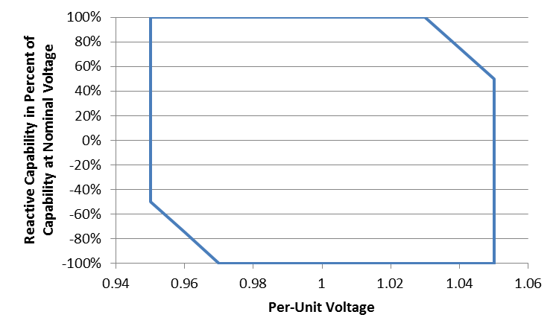
Figure 2-1 Required reactive capability as function of point of interconnection bus voltage. Positive percentage indicates overexcited (lagging) reactive power; negative percentage indicates under-excited (leading) reactive power.

Reactive Power Capability during Undervoltage Conditions
- The Resource shall have the capability to deliver reactive current to the LIPA transmission system (lagging, or overexcited operation) at the point of interconnection that is at least 33% of the Resource’s output current rating at nominal voltage when the positive-sequence voltage at the point of interconnection is less than 0.95 p.u., and greater than 0.5 p.u., of the nominal voltage.
- Injection of reactive current at point of interconnection voltage less than or equal to 0.5 p.u. of the nominal voltage is not required.
- Real current injection may be curtailed to meet the reactive current injection requirements during undervoltage conditions that are specified in this sub-clause.

Reactive Power Control Capability
The Resource shall have the control capability to regulate its reactive power in any of the following modes: constant reactive power, constant power factor, bus voltage regulation with droop. These control modes shall achieve specified performance at the Point of Interconnection, regardless of whether the Resource is composed of a single generation unit, or a multiplicity of individual generation units.

Constant Reactive Power Mode
- In the constant reactive power mode, the net reactive power at the Point of Interconnection shall be automatically maintained at a specified value or setpoint. The minimum range of adjustability for this setpoint shall at least cover the full range of required reactive power capability as specified in Sub-Clause 2.1 of this Annex.
- The steady-state reactive power flow into or out of the LIPA system at the Point of Interconnection shall be maintained at the more constraining of the reactive power regulation setpoint and the reactive power capability of the Resource as specified in Sub-Clause 2.1 of this Annex, within tolerances of +/- 2% of the Resource’s real power rating.
- Transient changes of voltage, for which the initial and final phase voltage magnitudes are within the normal range of operation (0.95 p.u. to 1.05 p.u. of nominal), and any changes of the Resource’s real power generation, shall not cause the net reactive power at the Point of Interconnection to vary outside of the specified steady-state reactive power tolerances for a duration in excess of 0.5 seconds.

Constant Power Factor Mode
- In the constant power factor mode, the net reactive power at the Point of Interconnection shall be automatically varied in proportion to the real power output, such that a constant power factor is maintained at a specified setpoint. The minimum range of adjustability for this setpoint shall be from 0.95 leading to 0.95 lagging.
- The steady-state reactive power flow into or out of the LIPA system at the Point of Interconnection shall be maintained at the more constraining of the constant power factor setpoint and the reactive power capability of the Resource as specified in Sub-Clause 2.1 of this Annex, within tolerances of +/- 2% of the Resource’s real power rating.
- Transient changes of voltage, for which the initial and final phase voltage magnitudes are within the normal range of operation (0.95 p.u. to 1.05 p.u. of nominal), and any changes of the Resource’s real power generation, shall not cause the net power factor to deviate from the specified steady-state tolerances for a duration in excess of 0.5 seconds.

Voltage Regulation Mode (with Droop)
- In the voltage regulation mode, the reactive power of the Resource shall be automatically varied to regulate the Point of Interconnection positive sequence voltage magnitude to a specified setpoint, offset by a droop function
- The minimum range of adjustability for the voltage regulation setpoint shall be from 0.95 to 1.05 p.u. of the nominal voltage
- The voltage regulation setpoint shall be offset by a droop function that is in proportion to the reactive power output of the Resource.
- The minimum range of adjustability for the droop function shall be from 0.04 to 0.30 p.u. voltage setpoint offset per per-unit reactive power output. The per-unit base for the reactive power output is the rated real power capacity of the Resource.
- The Resource shall not be required to provide reactive power greater than as specified in Sub-Clause 2.1 of this Annex in order to regulate voltage. Controls shall be designed to avoid “wind-up” of integral functions when the reactive power output is limited by capacity constraints.
- The voltage regulation function shall maintain the steady-state point of interconnection positive-sequence voltage magnitude to within ±0.005 p.u. of the specified voltage regulation setpoint, as adjusted by the droop function, to the extent that this voltage regulation performance can be achieved within the reactive capability limits of the Resource.
- The voltage-regulation function shall have a 0.1 second closed-loop response time under nominal system short-circuit level conditions. Response time is defined as the time from when a step stimulus is initiated (step in voltage regulation setpoint or switching of an external reactive device such as to cause a step change in the voltage) until the Resource reactive output has reached 90% of its final value.
- For a step change in the voltage regulation setpoint, the resulting voltage response shall not overshoot the final value by more than 10% of the change in steady-state voltages before and following the step.

Dispatch of Reactive Control Setpoints and Parameters
- The selection of the reactive control mode and setpoints shall be at the sole discretion of PSEG-LI System Operations.
- Changes in control mode and setpoints may be changed at any time. The Resource Owner shall be responsible for implementing any ordered changes immediately. In all cases, these changes shall be implemented within ten (10) minutes of issuance of the order by PSEG-LI System Operations.

voltage and Frequency Disturbance Performance
- In order to minimize power resource deficiencies in the LIPA system as a result of system voltage and frequency disturbances, which may affect multiple power generation resource facilities simultaneously, ride-through performance requirements are set forth in this clause.
- The term “remain on line” is used in this clause, and is defined to mean that the Resource retains the ability to maintain real and reactive power output or immediately recover real and reactive power output as specified in this Clause.

Low-Voltage Ride Through
- The Resource shall remain on line for the voltage disturbance caused by any single or multi-phase fault on the LIPA transmission grid, having duration equal to the lesser of the normal fault clearing time, plus any subsequent post-fault voltage recovery to the final steady-state post-fault voltage. The initial conditions prior to such fault may include outage of any one LIPA transmission element, inclusive of both circuits of a double-circuit line sharing common transmission tower structures.
- The Resource shall remain online for any voltage disturbance caused by a single-phase fault on the transmission grid with delayed clearing, plus any subsequent post-fault voltage recovery to the final steady-state post-fault voltage. Clearing time shall be based on the maximum backup clearing time associated with a single point of failure (protection or breaker failure) for any single-phase fault location inclusive of single-phase faults occurring simultaneously on different phases of multi-circuit transmission lines. The initial conditions prior to such fault may include outage of any one LIPA transmission element, inclusive of both circuits of a double-circuit line sharing common transmission tower structures.
- The Resource shall recover to 90% of its pre-fault current output within 50 ms of the recovery of the point of interconnection positive sequence voltage to 0.85 per-unit of the nominal voltage.
- The Resource shall recover to the lesser of its pre-fault real power output or the available primary power, within 100 ms of the recovery of the point-of-interconnection positive sequence voltage to 0.95 per-unit of the nominal voltage, subject to the availability of the primary energy source.
- The Resource shall remain online and maintain stable operation in the post-fault state for the degraded short-circuit level conditions resulting from any fault condition described in (a) and (b), excluding fault conditions for which the clearing requires complete isolation of the Resource from the LIPA transmission system.
- The Resource shall not be required to remain online for system low-voltage disturbances creating a positive-sequence voltage component less than specified in Figure 3-1 for the cumulative durations shown, nor shall it be required to remain online for unbalanced system voltage disturbances creating a negative-sequence voltage greater than specified in Figure 3-2 for the cumulative durations shown.
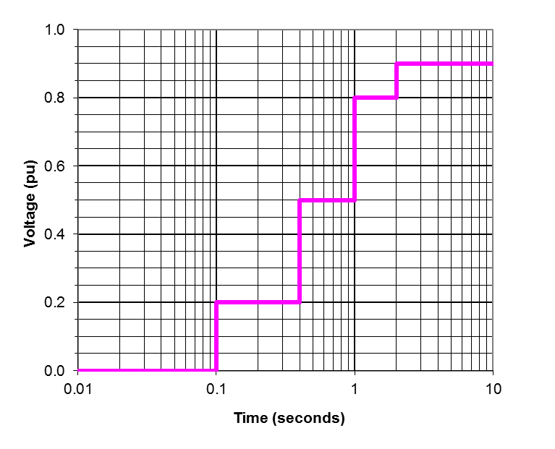
Figure 3-1 Minimum positive-sequence voltage ride through requirement.
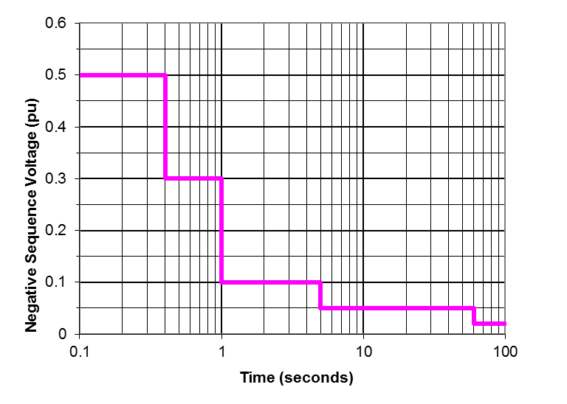
Figure 3-2 Maximum negative-sequence voltage ride through requirement.

High-Voltage Ride Through
The Resource shall remain on line for temporary overvoltages where the maximum phase-to-ground or phase-to-phase per-unit voltage, on any phase, is no greater than the magnitudes and durations specified in Figure 3-3, and which do not result in a negative-sequence component of voltage greater in magnitude and duration than specified in Figure 3-2.
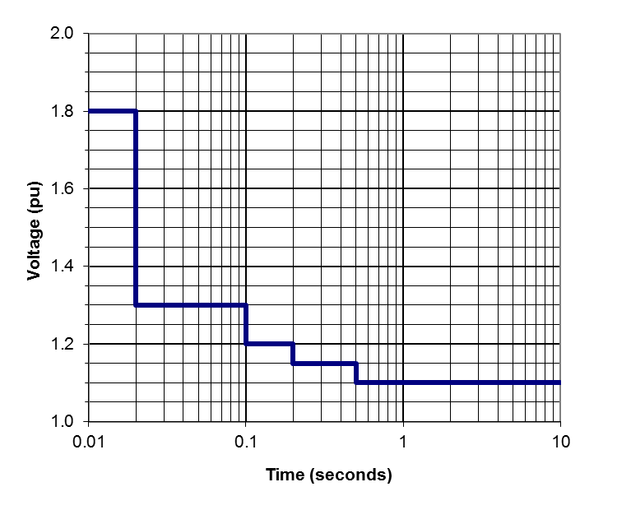
Figure 3-2 Maximum high voltage ride through requirement.

Voltage Disturbances within the Normal Magnitude Range
- Resources shall remain online for all deviations in voltage magnitude or relative phase angle that do not cause any phase voltage to be outside of the normal voltage range of 0.95 p.u. to 1.05 p.u. of nominal, and which do not cause a negative sequence component of voltage exceeding the magnitudes and durations specified in Figure 3-2.
- For all voltage disturbances within the normal magnitude range, as specified in (a), the real power output of the Resource shall not deviate more than 10% from the pre-disturbance real power level for greater than 100 ms, and shall not deviate more than 2% from the pre-disturbance real power level for greater than 500 ms, as a direct result of the voltage disturbance. This requirement does not limit power variations due to availability of the primary energy source (e.g., a change in solar irradiance) that is not related to the voltage disturbance.

Frequency Response and Ride Through
- The Resource shall remain online for all deviations in frequency less severe in magnitude and duration as specified in Figure 3-3.
- For over-frequency events exceeding 60.036 Hz, the real power output of the Resource shall be the lesser of the available real power and a power output limit that decreases at the rate of 0.33 p.u. of the pre-disturbance power level per Hz of frequency deviation above 60.036 Hz.
- For under-frequency events wherein the frequency is less than 59.964 Hz, the real power of the Resource shall be the lesser of the available real power and a power output limit that increases at the rate of 0.33 p.u. of the pre-disturbance power level per Hz of frequency deviation below 59.964 Hz. Limitations to the under-frequency response due to available real power (e.g., level of solar insolation) and equipment physical limitations shall not be deemed as non-compliance with this requirement.
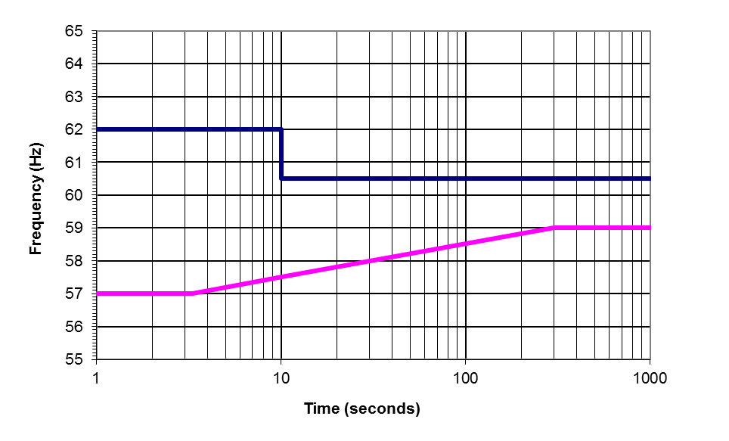
Figure 3-3 Frequency ride-through range.

Harmonic and interference Performance

Harmonic Current Limits
- Non-fundamental-frequency current components, at any given frequency, injected into the LIPA transmission system by the Resource shall be less than the values specified in Table 4-1. The per-unit base is the (rated) current of the Resource when delivering the rated maximum real power at a power factor of 0.95 at nominal voltage. The RSS metric is the square root of the sum of the squares of the individual current frequency components from harmonic orders 2 to 50.
Table 4-1 – Harmonic Current Limits
 | Harmonic Order
 | h < 17 | 17 ≤ h < 23 | 23 ≤ h < 35 | 35 ≤ h | RSS
Current Limit | 2.0% | 1.5% | 0.6% | 0.3% | 3.0%

- For resources having an aggregate power rating at a single point of interconnection to the LIPA transmission system greater than 20 MW, the IT product of the harmonic components shall be less than 10,000 A. The IT product is defined as follows:
Where:
h = Harmonic order
T_{h} = TIF weighting factor, as documented in IEEE-519, for the frequency of harmonic order h
I_{h} = Current injection at harmonic order h.
- The current distortion specifications are applicable to all frequency components above 120 Hz and less than or equal to 3 kHz. Interpolation of the weighting factors shall be used for non-integer harmonics.
- Harmonic current limitations specified in this sub-clause apply to the currents caused by the Resource, not inclusive of harmonic currents caused by background harmonic voltages existing in the LIPA transmission system exclusive of the Resource.

Harmonic Voltage Limits
- The Resource shall not cause an incremental increase in voltage distortion at any non-fundamental order from harmonic orders 2 to 50 by greater than 1% of the nominal voltage.
- The voltage TIF, as defined in IEEE-519, caused by the Resource, shall be less than 25.
- The voltage distortion specifications are applicable to all frequency components above 120 Hz and less than or equal to 3 kHz. Interpolation of the weighting factors shall be used for non-integer harmonics.
- These voltage distortion limitations apply to active contribution by the Resource, and exclusive of voltage distortion amplification caused by resonances of passive circuit components.

Power Line Carrier Interference
- Power line carrier (PLC) systems are used for protection communications on the LIPA transmission system. The communication channels are in the frequency range of 30 kHz to 500 kHz. Harmonic and electrical noise conducted or radiated from the Resource system shall not interfere with any LIPA power line carrier (PLC) system.
- In addition to potential interference due to noise injected in the PLC channel frequency range, experience with prior power electronic systems shows the possibility of PLC receiver input overload due to energy in the 4 kHz to 10 kHz frequency range due to PLC receiver input stage overload due to energy outside of the carrier frequency range. The contribution of harmonics and electrical noise injected into the LIPA system by the Resource shall not result in voltage across the drain coils of any LIPA PLC coupling capacitors greater than 5% of their design maximum.

Radio Frequency Interference
- The Resource owner is responsible for any radio frequency interference radiated from the Resource installation or the connection line between the Resource facility and the LIPA point of interconnection.
- The Resource shall not cause radio frequency noise to be radiated from any LIPA transmission line or substation that is of greater intensity than 200 uV/m measured at any point greater than 50’ beyond the perimeter of any substation, or 50’ from the centerline of any LIPA transmission line. Measurements of radio interference shall be in accordance with IEEE Standard 430-1986 (R1991), and made by instruments compliant with ANSI Standard C63.2-1996.

Control Performance

Stability
The performance of the Resource shall be stable and without poorly damped oscillations in real or reactive power, exclusive of variations caused by changes in the primary power resource (e.g., solar irradiance), for any system condition yielding a short-circuit capacity at the Resource point of interconnection greater than the minimum short-circuit capacity yielded by any N-1-1 outage contingency on the LIPA transmission system.

Control Interactions
- The Resource shall not engage in or cause adverse or unstable interactions with other controls, including generator excitation controls, capacitor switching controls, and transformer tap changer controls, or other power electronic systems including existing HVDC systems, other dynamic reactive support devices, or other non-synchronous generation resources.
- Resource owner shall have primary responsibility to investigate and correct any actual or potential interactions with any other power electronic-based transmission or generation system that is in commissioned service or under construction prior to the date of the commissioning of the proposed Resource.
- Respondent shall be required to cooperate with LIPA, PSEG-LI, and the party responsible for any new power electronic-based transmission or generation system installed or proposed to be installed after the commissioning of the proposed ESS. This cooperation shall include providing parameters and control characteristics necessary to investigate and correct any potential or actual interactions between the systems.

transient and Temporary Overvoltages
- The Resource shall not cause transient or temporary overvoltages at any point on the LIPA system more severe than the overvoltage envelope defined in Figure 6-1. The temporary voltage envelope for a given bus is defined as the plot of voltage versus time, for which the voltage value at any instant of time is the maximum instantaneous p.u. value of any phase-to-ground or phase-to-phase voltage magnitude (absolute value) during the preceding 16.6666 milliseconds. Overvoltage duration is defined as the total cumulative period of time that the TOV envelope is at or above the given magnitude as a result of a single initiating event.
- The Resource shall present an effectively grounded source to the LIPA transmission system.
- Isolation of the Resource shall not cause result in recovery voltages across any LIPA circuit breaker establishing the isolation, in excess of that circuit breaker’s transient recovery voltage (TRV) or voltage rating.
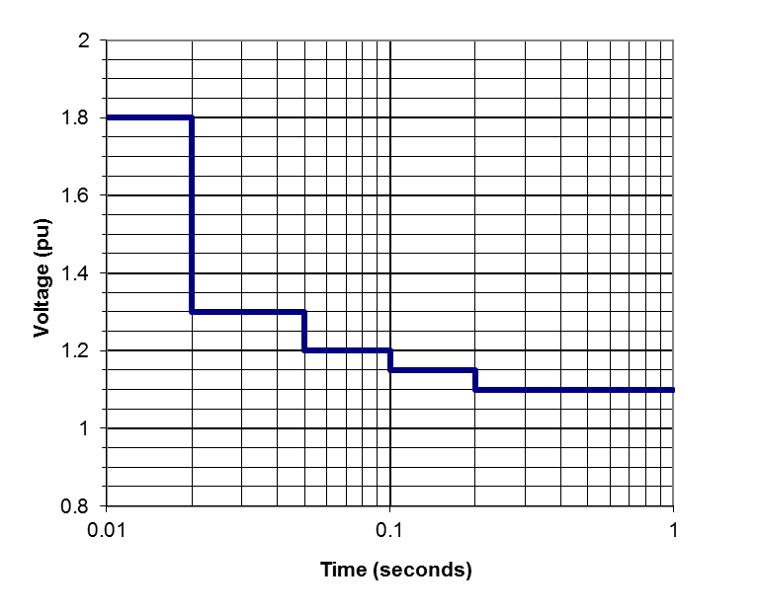
Figure 6-1 Limits to overvoltage caused by Resource

Short-Circuit Contributions
- Respondents shall fully describe the current contributions of the proposed Resource to near and remote faults. The short-circuit current contribution characterization shall include:
  - Three-phase, single-phase, phase-to-phase, and double-phase to ground fault types.
  - Characterization of fault current contributions in phase as well as sequence component formats.
  - Indication of the phase angle of the current contribution relative to the residual voltage value at the Resource terminals during the fault.
  - Description of non-fundamental-frequency current components.
  - Dynamic variations in the ac components of current contribution as well as decay of the dc component, if any.
- PSEG-LI shall assess whether the short-circuit contribution of any Resource is responsible for total fault currents in excess of the rating of any LIPA system circuit breaker or other component. The costs of upgrading any such equipment subject to excessive duty due to the Resource will be included in the evaluation of Resource proposals.

Required Dynamic Models

Positive-Sequence Fundamental-Frequency Model
- PSEG-LI shall be provided a model, implemented in the Siemens PTI PSS/E dynamic simulation software, Version 32.1.1, that accurately represents the control characteristics and dynamic behavior of the Resource in response to balanced voltage and frequency disturbances, to the extent that such can be validly represented in this type of simulation platform (up to 5 Hz bandwidth in the synchronous reference frame). This model shall be provided prior to the Resource being placed into commercial operation.
- A fully detailed model is required and a general model is not acceptable.
- The PSS/E model shall be validated for accurate representation of disturbances that are within the model’s appropriate range of application, using a validated electromagnetic transient model or full-scale testing.
- The PSS/E model shall be fully documented.
- The PSS/E model must be non-proprietary and shall be accessible to other utilities, system operators, asset owners, and other entities associated with the interconnected transmission network.
- The PSS/E model shall be updated by the Resource owner prior to any change to the Resource controls or control parameters that materially affects the dynamic performance.
- The Resource owner shall ensure compatibility of the provided PSS/E model with the version of PSS/E used by PSEG-LI, as well as compatibility of the latest PSS/E version released by Siemens PTI. Upgrades and modification of the models to maintain compatibility with these PSS/E versions shall be the responsibility of the Resource owner.

Electromagnetic Transient Model
- For a Resource, or an aggregation of Resource units at a single point of interconnection, having a maximum real power capacity of 50 MW or greater, PSEG-LI shall be provided an electromagnetic transients model, implemented in the PSCAD simulation software, Version 4.2 or later, that accurately represents the control characteristics and dynamic behavior of the Resource in response to balanced and unbalanced voltage, phase, and frequency disturbances with up to a 1 kHz bandwidth of simulation validity. This model shall be provided to PSEG-LI prior to the Resource being placed into commercial operation.
- The PSCAD model shall use the same power converter control software algorithms as used in the actual equipment, or a fully validated approximation of these controls that provides modeling fidelity across the specified simulation validity bandwidth.
- An averaged power converter model may be substituted for a full switching model, provided the averaged model provides valid representation over the specified bandwidth and represents the interactions across the converter, between the ac and dc sides.
- Documentation shall be provided establishing the validity of the model, such as comparisons between model results and full-scale test results for a sufficient range of tests.
- The PSCAD model may be proprietary, and be bound by reasonable non-disclosure agreements. The model must be made available to LIPA, PSEG-LI, PSEG-LI’s agents and consultants, and any other party as directed by PSEG-LI, provided that the party is not in direct competition with the Respondent or the Respondent’s Resource equipment manufacturer.
- The PSCAD model may be provided in a compiled, “black box” form such that the details of the model are not disclosed. Information needed to utilize the model, however, must be adequately documented.
- Information needed to utilize the model shall be fully documented.
- The PSCAD model shall be updated by the Respondent prior to any change to the ESS controls or control parameters that materially affects the transient or dynamic performance.
- The Respondent shall ensure compatibility of the provided PSCAD model with the version of PSCAD specified by PSEG-LI. Upgrades and modification of the models to maintain compatibility with new PSCAD versions shall be the responsibility of the Respondent.

Appendix B
LIPA Substations Not Suitable for Injection of Renewable Resources
- Central Islip
- MacArthur -Islip RR
- Pinelawn
- Peconic
- Wildwood
- Edwards
- Moriches
- Eastport
- William Floyd
- Ridge
- Riverhead
- Buell
- East Hampton

Appendix C

Following are the areas that are desirable from a planning perspective to avoid/ defer potential T&D reinforcements.

1. East End - South Fork east of Canal, North Fork east of Jamesport (69 kV or 23 kV POI)
2. Far Rockaway Region - Valley Stream & Southwest Nassau /NYC (~80 MW injection limit depending on interconnecting substation) (69 kV POI)
3. Glenwood Region – Northwest Nassau area (Roslyn, Carle Place, Glenwood, Lake Success substations) (~300 MW injection limit depending on interconnecting substation) (69 kV or 138 kV POI)
4. RFI projects
- Eastport/Moriches Region
- Plainview/Woodbury
- Hempstead
- Hauppauge, Central Islip, Pines, Pilgrim, Indian Head
- Navy Road
5. Smithtown Region- North of Jericho Turnpike between East Northport/Fort Salonga and Stony Brook (69 kV POI)
6. West Brookhaven Region – Central region of Suffolk county between Holbrook and Brookhaven (Holtsville LNG, West Yaphank, Yaphank, North Bellport, William Floyd substations) (69 kV POI)
7. South Shore Nassau Suffolk County Region – (Bellmore, Massapequa, Sterling, Lindenhurst substations) (69 kV POI)
8. Huntington Region - (Huntington, West Neck, Halesite substations) (23 kV POI)
***It is noted that Planning is willing to meet with potential bidders to discuss potential siting locations and needs. This is to provide specific information regarding the ability to interconnect at specific substations, (e.g., space limitations, voltage levels). Creation of new substation for projects is an option. All projects are subject to PSEG Long Island’s Long Island Local Reliability Interface Transfer Capability Test as posted on website (https://www.psegliny.com/files.cfm/LI-localreliability.pdfs.)

The Respondent has the option of submitting the Annual Energy Production Forecasts for each of the 20 years of the contract or to provide a degradation factor that will be applied for each year.

